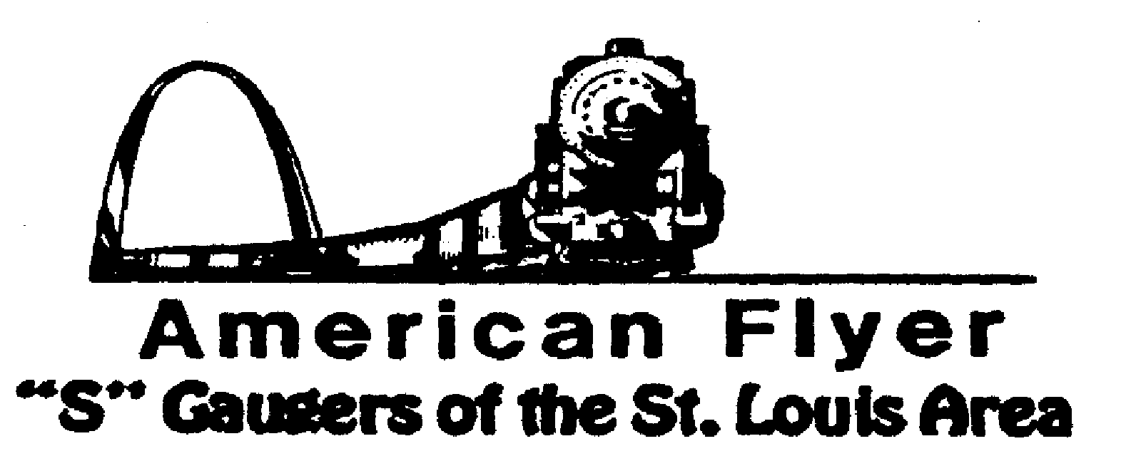

Website: www.trainweb.org/afsgsla/ E-Mail: afsgsla65@gmail.com
_____________________________________________________________________
AFSGSLA LETTER
January 2022

AFSGSLA Club Events and Related Activities:
Events are slowing down again due to the rise in COVID cases. Several AFSGSLA members have had it and we are happy to report that we are not aware of any serious complications.

As with the last several newsletters, we are combining the planned club events and the other related activities. Although we will not necessarily participate in some of the following events as a club, they are included in this somewhat comprehensive listing for your information. We suggest you keep this newsletter for your future reference and attend our club meetings for full details.

Actual Scheduled Events (obviously subject to change at the whim of some government official)

Saturday and Sunday, January 29 -30, 2022: Great Train Show, St. Charles Convention center. We have been accepted for this show. Placement is in the main room. Set-up will be 1 pm Friday. Show times are 10am-4pm both days. Barry Dolan is coordinating.
Saturday, February 19, 2022: Pacific Eagles Train Show. 10:00 a.m. to 3:00 p.m. 707 Wet Congress Street, Pacific, Missouri. Admission is $3.00.
Saturday, March 5, 2022: Swap Meet at National Museum of Transport. It will be in the Earl C. Lindburg Automobile Center from 9am to 2 p.m. Vendor set up 7:00 a.m. General admission $3.00, Vendors $20.00.
Saturday, May 14, 2022: After the storm train show at Meramec Elks Hall, 10 a.m. to 2 p.m. It is located at 1515 Miller Road in Imperial, MO 63052. $3.00 at the door. And no, it is not far at least for us South County guys. It is only one exit after MO 141.
August 12, 13 &14, 2022: NMRA convention in Collinsville, Illinois. There is the possibility to display our sectional layout for the 3-day show, this would be for exposure only, there would be no compensation. A decision has not yet been made, but we are leaning to declining.
September 2022: Cliff Saxton once again reserved September for a club meeting.
Saturday and Sunday, October 8 & 9, 2022: Mississippi Valley N Scalers (MVNS) show at the Kirkwood Community Center, Kirkwood MO. No word yet on whether we will be displaying our sectional layout this year.

What’s been happening?

October 9, 2001: Paul Voegtle hosted an in-person Saturday meeting at his farm in New Athens, Illinois. This was an excellent meeting with lots of good food and conversation.
November 5th thru 7th 2021 - The Badgerland S Gaugers hosted the 45th Annual Fall S Fest. As usual a few AFSGSLA attended. Please see the write-up under this and that.
November 13, 2021: Dupo Train Show We displayed the double helix. Barry Dolan coordinated.
Saturday and Sunday, November 27-28, 2021: Great Train Show, Collinsville Convention center. We displayed our sectional layout. Barry Dolan coordinated.
Saturday, December 4, 2021: TCA train Show at Lutheran church in Olivette MO. We displayed our sectional layout. Barry Dolan coordinated.
Tuesday, December 7, 2021: John Nosari Open House John hosted an open house like he did 2 years ago. Lunch was served with his signature Italian Roast Beef and other fixings. John has continued making progress on his two layouts. A very enjoyable time was had by all who attended.

AFSGSLA’s Club Order of Special Cars:
As always, if you are interested in participating in these club orders, it would be to your advantage to attend the club meetings where details are made available and arrangements are finalized.
---The status of the Special Cars previously ordered have all been delivered.

2020 SFest Cars - There will be two different Milwaukee Road (what else being in Milwaukee) 2 Bay Offset Hoppers with black coal loads. The cars are $55.00 each (plus the registration fee of $18.00) if picked up at the S FEST. These will now be the 2021 SFest cars. NOTE: Badgerland S Gaugers has these cars in stock, so you will not have to wait months, or years, for them.

This and That

St. Louis Lionel Railroad Club – The club has vacated the building at the end of October. What was salvaged was put in a storage locker until a new location can be found. More as it becomes available.
2021 Fall S Fest Report – The S Fest happened as planned. David Stevens (aka Mr. Incline Challenge) did not attend this year, but he did write a very detailed book on the care and set-up of the incline challenge. We took it to Milwaukee, but did not set it up due to a lack of contestants. Because of COVID, all small room activities (clinics, etc.) were cancelled and sign-up sheets for the races and incline challenge were never made up. As might be expected, this S Fest was smaller, but in my opinion just as good. There were bargains to be found on the trading floor, a model contest and silent auction, all in the main room. The banquet was one of the best ever and a nice touch is they sold bottles of wine for $10.00 to compliment your dinner.

2022 Fall S Fest – As of now, there is no 2022 S Fest scheduled. Unfortunately, State Line had to decline sponsoring it. The 2023 S Fest in Chicago is currently a go. There is a small possibility that the Minnapolis club might pick up the 2022 S Fest as they already had planned a cancelled convention.

Midwest Money Layout Open House - Sponsored by the Midwest Money Company, on the First Sunday of every month from 11:00 A.M.to 4: P.M. They are located at 5901 Hampton, St. Louis MO just across Holly Hills Street. The layout is rather large, fully developed scenery 3 rail O-Scale layout. This rather large layout may be one of only a very few which can be claimed to be 100% complete. This location is in South St. Louis City, roughly hallfway between Chippewa and Gravois

Special notice from David Stevens: Dave has had it easy recently, but as you can see, we are hoping to get back to in person club meetings now in 2022. We have had a number of our faithful club members who have volunteered to host future meetings. Although our David Stevens is especially pleased with the excellent response to his recent requests, he tells us that we still need club members to volunteer to host club meeting in the future. He states that if you have not hosted a meeting recently---or ever---please carefully consider doing so. It is a great way to “pay your dues” and it really is not much trouble to host a club meeting (the club pays our host a modest fee to offset expenses for refreshments). We have often said (and our hosts have agreed) that there is no surer way of getting your train room shaped up then hosting a club meeting. David Stevens will help you with the details, if you just contact him at Telephone: 314/ 921-1127 or stevens8128@sbcglobal.net.

Notes from your Co-Coordinators!

TOM SCHNUR
AFSGSLA Co-Coordinator
afsgsla65@gmail.com

RICK ARCHESKI
AFSGSLA Co-Coordinator
rcheski@charter.net

That’s it for now, more later:
GARY MUELLER
AFSGSLA Newsletter Editor
gmatmueller@aol.com

-And remember, “It’s just for the fun of it!”

